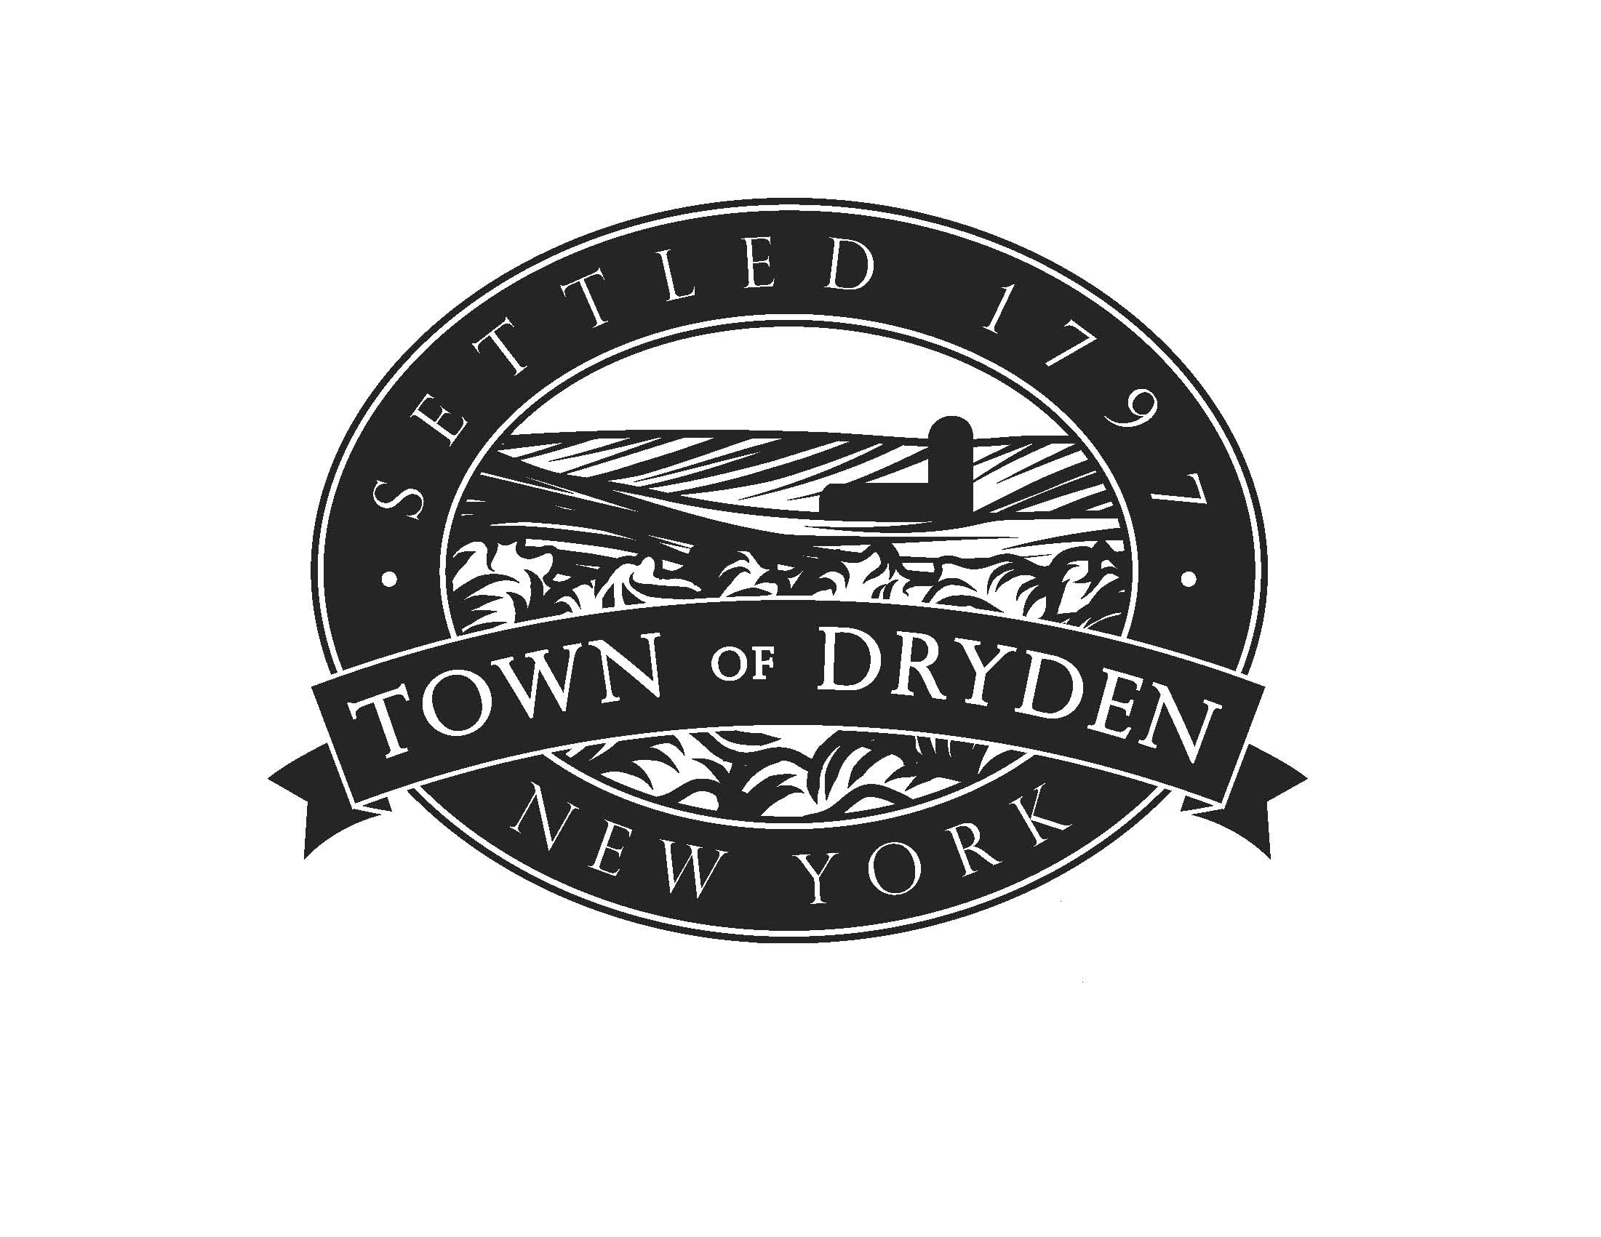
Planning Department
93 East Main Street
Dryden, NY 13053

T 607 844-8888 Ext. 216
F 607 844-8008
joy@dryden.ny.us

www.dryden.ny.us

Director of Planning Ray Burger Code Enforcement Officer Kevin Ezell
Code Enforcement Officer David Sprout
Zoning Officer David Sprout
Stormwater Officer David Sprout
Administrative Coordinator Joy Foster

General Permit Application – Sheet 1 General Information
DO NOT FILL IN SHADED SECTIONS

__________________ ___________________ ______________________
Date: Tax Parcel #: Zoning District:
(Complete ) Project
Address: _____________________________________________________________________________________

Project Description:____________________________________________________________________________
_____________________________________________________________________________________________
_____________________________________________________________________________________________

Principal Use: Residential__________________ Commercial:________________ Other: ___________________

Permit(s) Required: __ Building __ Zoning __ Special Use __ Site Plan Review __ Subdivision __ Pool
__ Heating __ Demolition __ Pre-built Shed

To be completed by Planning Department personnel:

Worksheets / sections required:

____ Site Plan Sketch

____ Site Plan Review

____ Special Use Permit

____ Notice of Ground Disturbance

____ Zoning Permit

____ Varna Compliance Worksheet

____ Residential Design Guidelines Compliance

____ Commercial Design Guidelines Compliance

____ Sign Compliance Worksheet
____ Driveway or Roadcut Compliance

____ Notices and Disclaimer Acknowledgement

____ Agricultural Data Statement

____ County Review

____ Minor Subdivision

____ Major Subdivision

____ Demolition

_____ Lot line Adjustment

Notes: _____________________________________________________________________________________________

_____________________________________________________________________________________________

Permit Application - Contact Information

Owner - Print name: ______________________________________________________________________________________
Owner Signature required & dated: ______________________________________________________________
Address: _________________________________________ City: ___________________ State: ___________ Zip Code: _______
E-mail: _________________________________________ Telephone No: ___________________________________________
Emergency Contact: ______________________________ Telephone No.: ___________________________________________

Agent / Applicant - Print :___________________________________________________________________________________
Address: _________________________________________ City: ___________________ State: ___________ Zip Code: _______
E-mail: __________________________________________ Telephone No: ___________________________________________

General Contractor:____________________________ License #_______________________________________________
Address: ________________________________________ City: ___________________ State: ___________ Zip Code: _______
E-mail: __________________________________________ Telephone No: ___________________________________________

Mason Contractor:_____________________________ License #_______________________________________________
Address: ________________________________________ City: ___________________ State: ___________ Zip Code: _______
E-mail: _________________________________________ Telephone No: ___________________________________________

Electrical Contractor:___________________________ License #_______________________________________________
Address: ________________________________________ City: ___________________ State: ___________ Zip Code: _______
E-mail: __________________________________________ Telephone No: ___________________________________________

HVAC Contractor:______________________________ License #_______________________________________________
Address: ________________________________________ City: ___________________ State: ___________ Zip Code: _______
E-mail: __________________________________________ Telephone No: ___________________________________________

Plumbing Contractor:___________________________ License #_______________________________________________
Address: _________________________________________ City: ___________________ State: ___________ Zip Code: _______
E-mail: __________________________________________ Telephone No: ___________________________________________

Surveyor:____________________________________ License #_______________________________________________
Address: ________________________________________ City: ___________________ State: ___________ Zip Code: _______
E-mail: __________________________________________ Telephone No: ___________________________________________

Note: The Town of Dryden will keep your contact information private.

* *CUT: ------------------------------------------------------------------------------------------------------------------------------------------------------------------------------ **
Application from ___________________________________________________ for _______________________________________________ Project Site __________________________________________________________________ received on __________________________
Payment received $______________________________ Cash Check # Credit Card (circle one)
Signature of receiver ____________________________________________________________ Date _________________

