Pictorial Layout of the Project
TAX PARCEL #: 44.-1-13.412
1610 Dryden Road

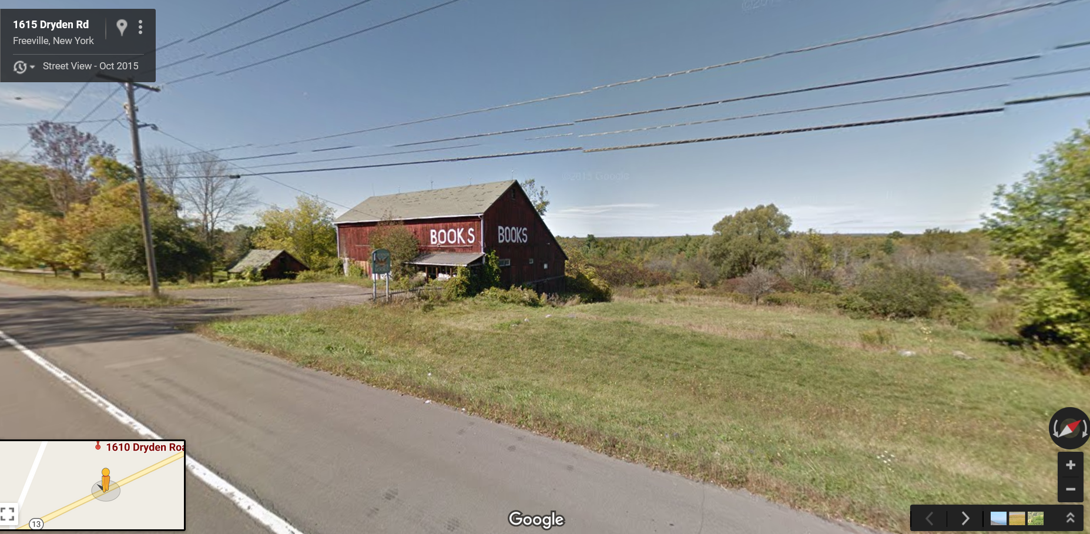
Route 13
Area for display of trailers
Existing Sign
NYSEG Light
Parking Area
Area for storage of trailers
Behind the Barn

