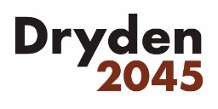
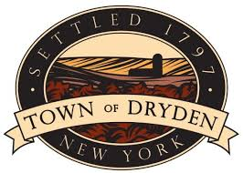

Town of Dryden

93 E. Main Street,

Dryden, NY 13053

PRESS RELEASE

FOR IMMEDIATE RELEASE Contact: Ray Burger
March 13, 2020 Phone: (607) 844-8888 x.216
March 25th Public Meeting for the Comprehensive Plan Update is Cancelled due to Public Health Concern

Dryden, N.Y. – Due to developing public health concerns and out of an abundance of caution, the Town of Dryden Comprehensive Plan Steering Committee has decided to cancel the Public Workshop and Open House that had been scheduled for 6 pm on March 25, 2020 at the Dryden Fire House on 26 North Street in the Village of Dryden. The meeting will be rescheduled for an appropriate future date. To learn about and participate in the ongoing Comprehensive Plan Update, please visit the project website: www.dryden2045.org

###

